**Pinning Insects**

|  |  |
| --- | --- |
| Location  Date  Your Name  **Figure 1. Label 1** | Class  Family  **Figure 2. Label 2** |

# 

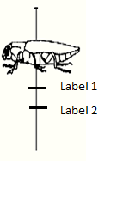

**Figure 4. Insect with label**